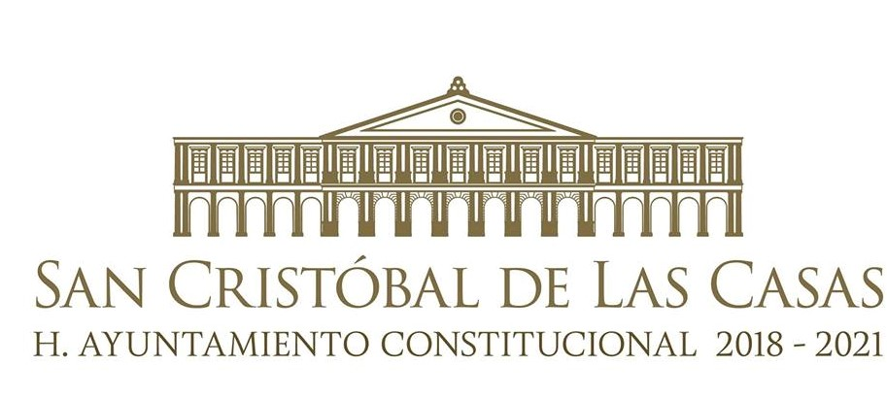

Mrs. Jerónima Toledo Villalobos

**Constitutional Mayor**

**San Cristóbal de Las Casas, Chiapas**

**City Council 2018 – 2021**

**San Cristóbal’s Background.**

Before the arrival of the Spanish conquerors, the actual Valley of San Cristóbal de Las Casas was called ***hueyzacatlán*** (Nahuatl word that means “next to the great grass”), according to testimonies from the Spanish explorers and settlers; In the past, there were also many other local names for the region like: “*tzequil*” (skirt) and “*jovel*” (a grass similar to a straw).

.

The first colony, funded on March 31, 1528 by Diego de Mazariegos, was called “Villa Real”. Some years later, on June 21, 1529, Juan Enrique de Guzmán changed its name to “Villaviciosa”

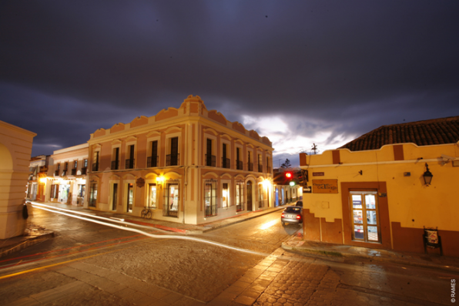

On September 11, 1531, the name of the city was changed once again to “Villa de San Cristóbal de los Llanos” and, later on, it was replaced by the name of “Ciudad Real” on July 7, 1536, which remained until July 27, 1829, when it was restored to “San Cristóbal”.

As of May 31, 1848, the part “Las Casas” was added to the official name of the city, to honor the Sevillian friar Fray Bartolomé de Las Casas, first Bishop of the Diocese.

Towards 1934 only “Las Casas” was left as the proper name of the city, but nine years later, on November 4, 1943, it acquired the current name: **San Cristóbal de Las Casas.**

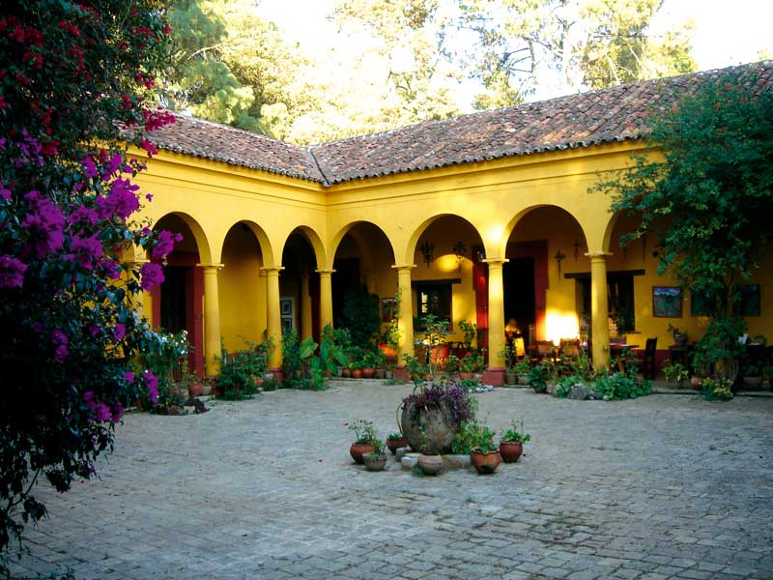

**San Cristóbal, today.**

San Cristóbal de Las Casas, placed in the physiographic region of “Los Altos de Chiapas”, is located at an altitude of 2,113 meters above sea level, with a humid temperate climate.

Los Altos de Chiapas is a mountainous region. Its diversity in flora registers a main vegetation of coniferous forest (pine-oak) especially in its several ecological reserves of Cerro del Huitepec, Rancho Nuevo, the La Kisst mountain wetlands, the María Eugenia mountain wetlands and recently the Reserve Ecológica Gertrude Duby and the Moxviquil Reserve, the Arcotete Ecotourism Park and the Mammoth Caves, among others.

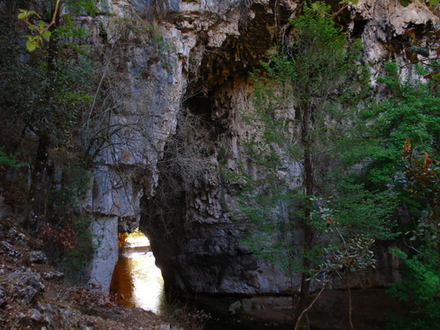

In terms of its fauna, the municipality is home of 368 species registered species of wildlife. The most common are: ocotera snake, cold weather naucaya snake, picamadero ocotero, pintail hawk, wild boar, flying squirrel, bat, white-back skunk, wild deer, cantil, boa, false nauyaca, rock iguana, river iguana, olive chachalaca, roadrunners, striped owl , white-tailed hawk, weasel, copetona magpie, striped skunk, spotted skunk and opossum. In the municipality a *realictica* species exists (that is to say, a species unique in the world) called **popoyote** (Profundulus hildebrandi, Miller 1955), this information can be found in the University of Sciences and Arts of Chiapas, Museum of Zoology, School of Biology

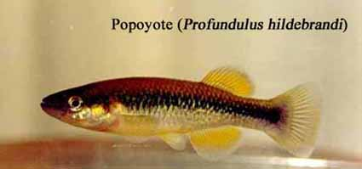

As for its important tourist attractions, San Cristobal de Las Casas has a wide collection of monuments and historical buildings that date back to the time of its foundation by the Spanish Captain Diego de Mazariegos, such as: La Casa de las Sirenas (residence of the founder) and which now servs as a hotel. There are also important temples with baroque architecture, of which the temple of Santo Domingo de Guzmán, the Catedral de la Paz, the Temple El Calvario, the Temple of La Merced, the Temple of Santa Lucia, Temple of San Cristóbal Martir, San Nicolás, Caridad, San Francisco de Asís and San Diego, among others.

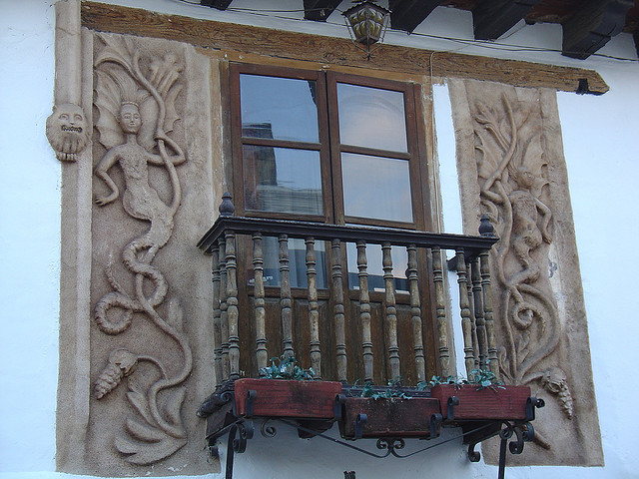

Likewise, there is a wide variety of infrastructure elements that were built alongside the temples and that are, in turn, significant for the identity of “los coletos” (name given to those born in San Cristóbal de Las Casas) such as: Municipal Palace, the Arco del Carmen (Mudejar arch that marks the old entrance to San Cristóbal de Las Casas), the ex-convents of La Merced, Santo Domingo and El Carmen; the Bicentennial School of Law, the House of Education, the José Castillo Tiélmans Market, etc.

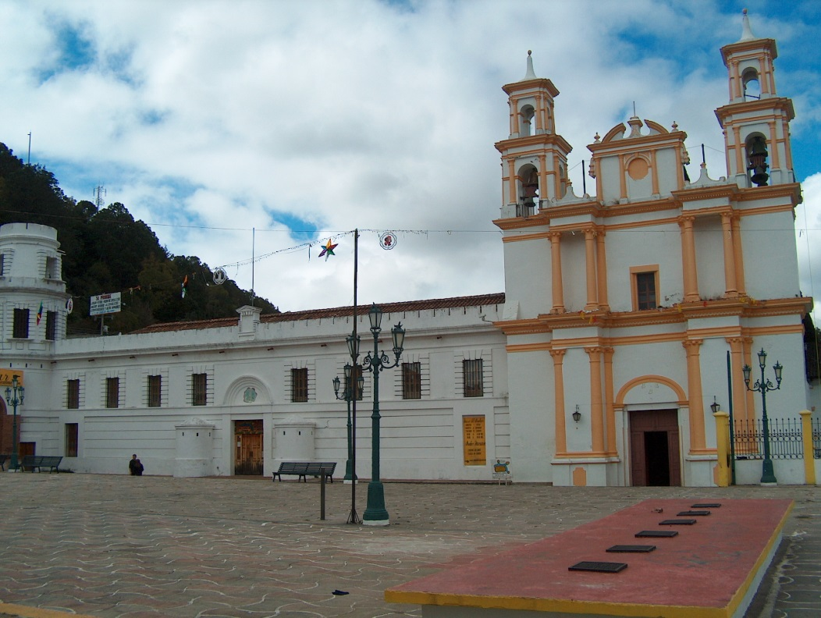

The art of San Cristóbal de Las Casas can be seen in different places that bring together part of the history, uses and customs and other historical legacy of the people of San Cristobal. Among them, the museums of Los Altos de Chiapas (reopened in October 2015 by the President of the Republic) and where one can find exhibits of pieces of the Jesuit and Dominican orders, who along with the Mercedarian friars established the first convents upon the arrival of the Spanish men; it also has two rooms with a permanent exhibit of the Pellizzi Textile Collection as well as the Oaxaca Room; the Museo and Casa Na Bólom (Casa del Jaguar) that has one of the most important archives of the Lacandon Jungle, it was created by its owners Gertrude Deby and Frans Blom, during their years of expedition and protecting this great “lung” of Mexico.

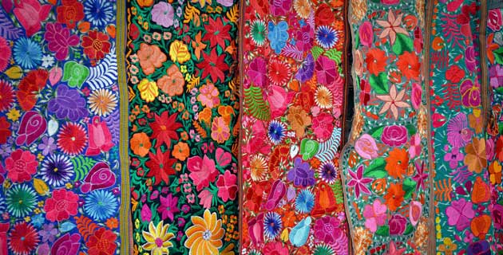

The Amber Museum of Chiapas, that is hold in the former Convent of La Merced, exhibits artisan pieces of this mineral, from the mines of the town of Simojovel, whose works are internationally famous and whose annual meeting allows Chiapas artisans to promote and market the beautiful work they do. In addition, the Jade Museum, the Cocoa Museum, and the visit to the temples, which hold true treasures in terms of religious works.

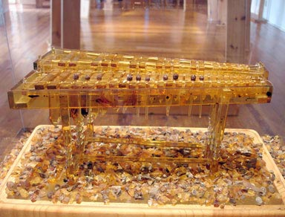

Many artisans and craftsmen and women form Los Altos de Chiapas sell their work on the streets and parcs of San Cristóbal de Las Casas where visitors can find a wide variety of traditional textiles and ceramics, handmade in their communities. San Cristóbal is a unique center in the world; it brings together the many vibrant cultures of the peoples living in the region.

As for its uses and customs, the life of San Cristóbal has as its main axis the festivities of its 10 historical neighborhoods, which to the rhythm of the Chiapas marimba are the religious manifestation of the ancient settlers, which has been inherited in traditions and legends of the different Saints to whose names were given to the neighborhoods, as well as the origin of its first settlers (Barrio de Mexicanos, Tlaxcala, Cuxtitali, El Cerrillo, etc.). In these neighborhoods, the visitor can also appreciate the regular coexistence of indigenous people, the “ladinos” (non-indigenous people) and foreign visitors who base their relationship mainly on commerce, making the pluricultural mosaic evident with full respect and within a framework of civility.

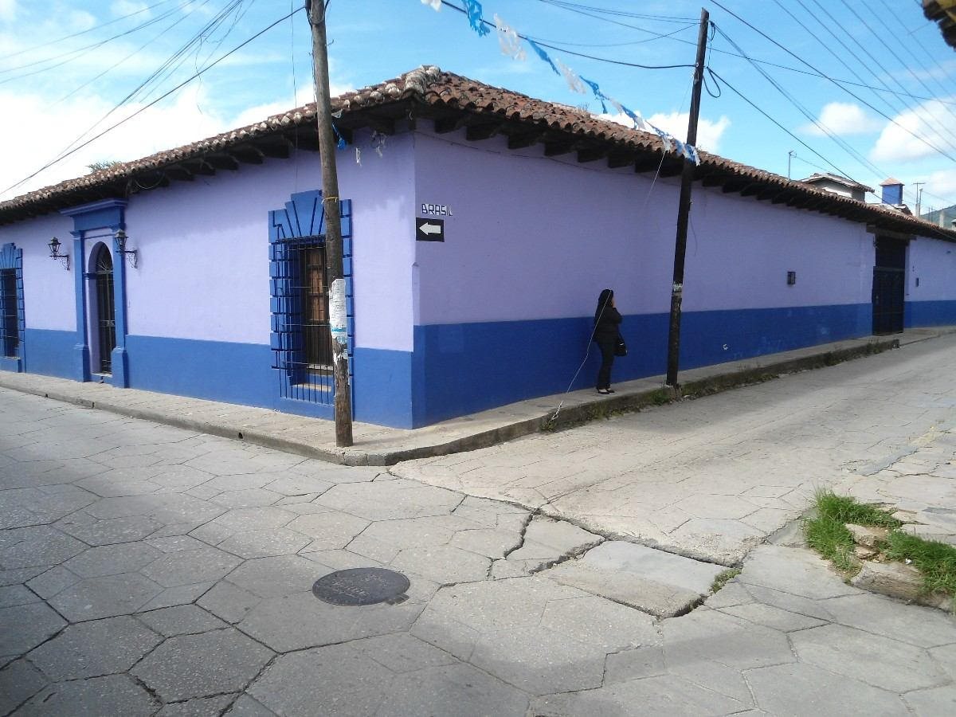

Its gastronomy presents a wide variety of regional sweets such as chimbos, crystallized fruits and syrup, egg yolk sweets, cajeta, nougats, sweet potatoes, peanut sweets, mistelas, ponches and a large variety of typical tamales such as “de bola” or the "untado", different from those of the rest of the country.

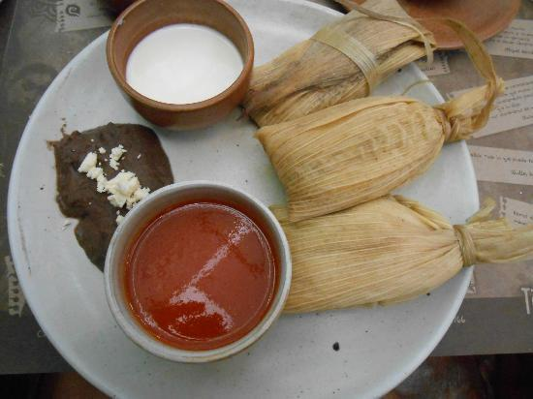

We also find a variety of typical food, highlighting the "Cochito", the "Sopa de Pan", and the embutidos and carnes frías, a legacy of the Spanish conquerors that today are handmade with a peculiar seasoning of the highest quality.

The previous elements allowed San Cristóbal de Las Casas to enter the list of Pueblos Mágicos (Magical Towns) and in the present, the local government is developing different projects, with the purpose rising awareness among citizens and visitors about aspects of conservation, preservation and maintenance of these beautiful public spaces.

On December 9, 2012, the City Council and the Government of the State of Chiapas signed the Letter of Intent to achieve the inscription of San Cristóbal de Las Casas on the tentative list of UNESCO to aspire to obtain the declaration as Mixed Cultural Heritage of Humanity, which entails a clear commitment to the rescue and preservation of environmental riches and historical monuments, as well as the promotion of the culture, uses and customs of San Cristóbal.

Although this appointment has not yet been reached, on December 11, 2015, San Cristóbal was recognized as the first UNESCO Creative City of Crafts and Folk Art in Mexico.

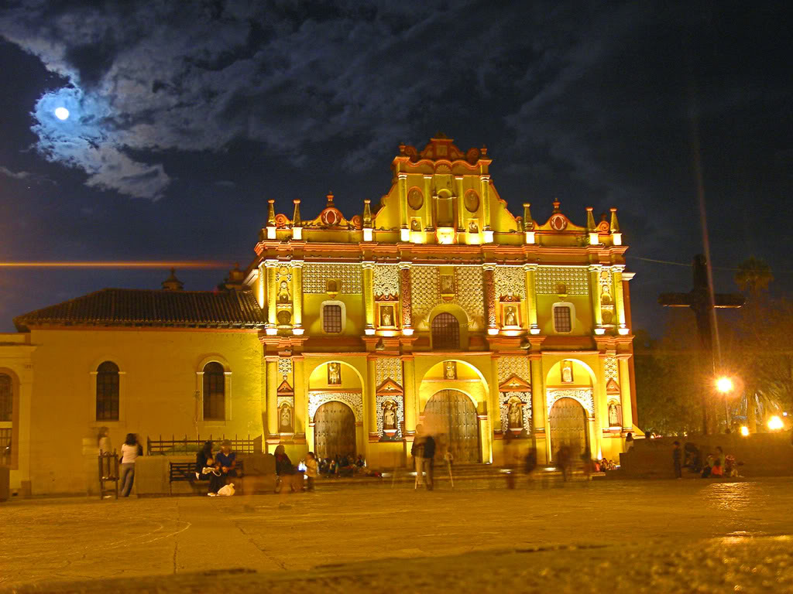

San Cristóbal is, therefore, the most important place in Chiapas in terms of cultural development and tourist attraction based on the intangible cultural assets that make up the indigenous people of the Altos de Chiapas. For this reason, it has become a mandatory tourist destination for those who visit Chiapas. It is also a meeting center for conventions, international summits and the headquarters of Non-Governmental Organizations, as well as the International Academy for the investigation of social phenomena, especially related to indigenist research.

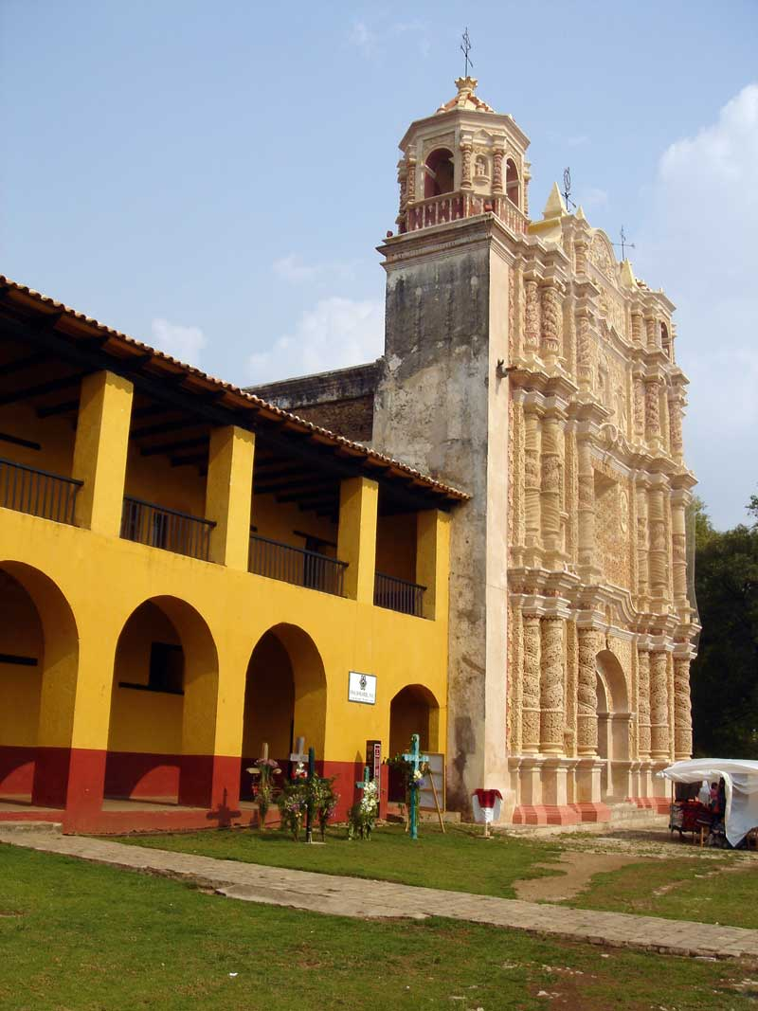Today, 492 years after its foundation, San Cristóbal de Las Casas intends to expand its relationships and achieve, through inter-institutional agreements, to be a participant in the development of other distant communities for the mutual benefit of cultural, academic and socio-economic exchange. We are convinced that unity and cooperation are currently the engines of sustainable development that is the world priority in today's times.

**Sister Cities:**

* Bandera de España [Ciudad Real](http://es.wikipedia.org/wiki/Ciudad_Real), [Ciudad Real](http://es.wikipedia.org/wiki/Ciudad_Real), Spain
* Bandera de México [Oaxaca de Juárez](http://es.wikipedia.org/wiki/Oaxaca_de_Ju%C3%A1rez), [Oaxaca](http://es.wikipedia.org/wiki/Oaxaca), [México](http://es.wikipedia.org/wiki/M%C3%A9xico)
* Bandera de los Estados Unidos [Asheville](http://es.wikipedia.org/wiki/Asheville), North Carolina, United States
* Bandera de Guatemala [Quetzaltenango](http://es.wikipedia.org/wiki/Quetzaltenango), Department of [Quetzaltenango](http://es.wikipedia.org/wiki/Quetzaltenango_(departamento)), [Guatemala](http://es.wikipedia.org/wiki/Guatemala)
* Bandera de Guatemala Imperial Ciudad de Cobán, Alta Verapaz, Guatemala.
* Bandera de México [San Miguel de Allende](http://es.wikipedia.org/wiki/San_Miguel_de_Allende), Guanajuato, México
* Bandera de México [Tuxtla Gutiérrez](http://es.wikipedia.org/wiki/Tuxtla_Guti%C3%A9rrez), Chiapas, México
* Bandera de México Comitán De Domínguez, Chiapas, México
* Bandera de México Chiapa de Corzo, Chiapas, México.
* Taxco de Guerrero de Alarcón, México



* Bandera de México Xico, Veracruz, México
* Bandera de México Tacotalpa, Tabasco, México
* Popayán, Colombia

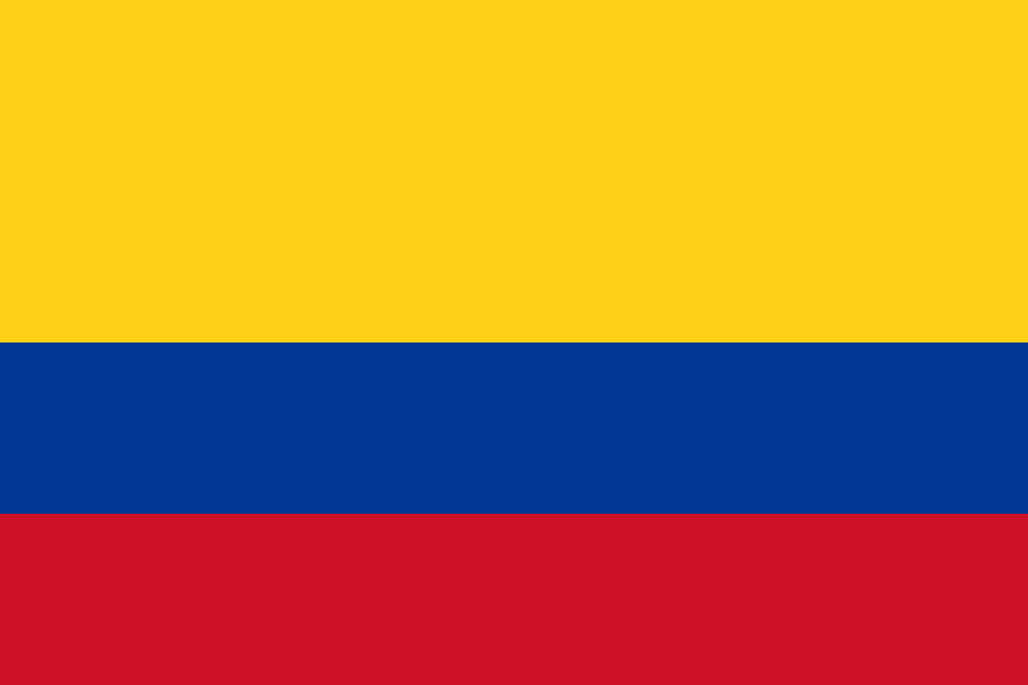

**Municipal Goals**

* Promotion of tourism, as a way to achieve more and better jobs.
* Security and tranquility in the city.
* Rescue, promotion and preservation of the historical heritage built.
* Promotion of sustainable development, orderly and harmonious growth with the environment.
* Cultural promotion, strengthening of identity.
* Transparency in accountability.

**Projection**

We hope that for this 2018-2021 period, this great project will be achieved by increasing local, state, national and international dissemination. In this way, it is intended to continue among the most visited cities in the country and at the same time establish a development model to follow for other municipalities that hold the title of Pueblos Mágicos.

Currently San Cristóbal de Las Casas, Chiapas, is a Magical Town and Creative City of UNESCO in the category of CRAFTS and FOLK ART.

